**CHAPTER 4**

**SIMULATION AND IMPLEMENTATION OF VIDEO STABILIZATION ON MATLAB AND FPGA**

1. **Simulation Structure in MATLAB**

This simulation shows how to stabilize a video that was captured from a jittery platform. One way to stabilize a video is to track a salient feature in the image and use this as an anchor point to cancel out all perturbations relative to it. This procedure, however, must be bootstrapped with knowledge of where such a salient feature lies in the first video frame. In this simulation, a method of video stabilization was explored that works without any such a priori knowledge. It instead automatically searches for the "background plane" in a video sequence, and uses its observed distortion to correct for camera motion.

This stabilization algorithm involves two steps. First, the affine image transformations is determined between all neighboring frames of a video sequence using the estimateGeometricTransform function applied to point correspondences between two images. Second, the video frames are wrapped to achieve a stabilized video.

1. **Read Frames from a Movie File**

The first two frames of a video sequence are read as intensity images since color is not necessary for the stabilization algorithm, and because using grayscale images improves speed. Both frames are being shown below side by side, and a red-cyan color composite is produced to illustrate the pixel-wise difference between them. There is obviously a large vertical and horizontal offset between the two frames.

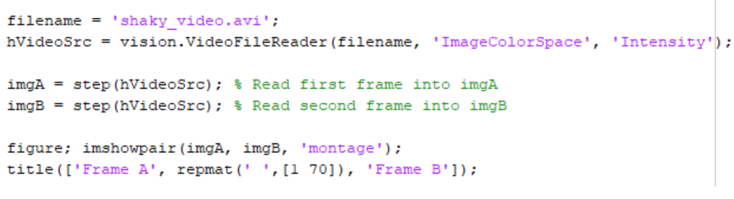

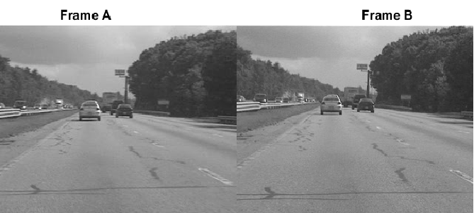

Figure 4.1. The First Two Frames of a Video Sequence

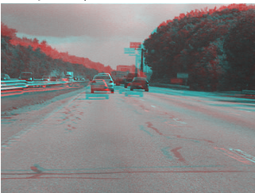

Figure 4.2. Red-cyan Color Composite Between Two Frames

(Frame A = red, Frame B = cyan)

1. **Collect Salient Points from Each Frame**

The goal of this step is to determine a transformation that will correct for the distortion between the two frames. The estimateGeometricTransform function can be used for this, which will return an affine transform. This function must be provided as input with a set of point correspondences between the two frames. To generate these correspondences, first, points of interest are collected from both frames, then select likely correspondences between them.

In this step MATLAB produce these candidate points for each frame. To have the best chance that these points will have corresponding points in the other frame, points around salient image features are needed such as corners. For that, simulation uses the detectFASTFeatures function, which implements one of the fastest corner detection algorithms.

The detected points from both frames are shown in the figure below. Observe how many of them cover the same image features, such as points along the tree line, the corners of the large road sign, and the corners of the cars.

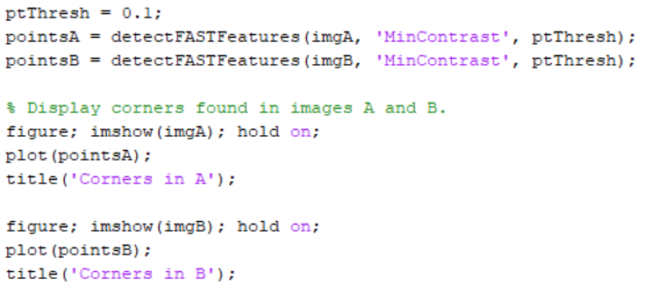

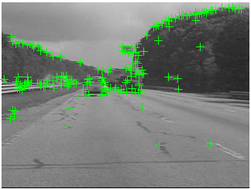

Figure 4.3. Corners in Frame A

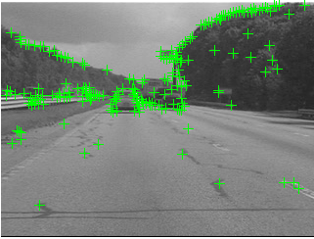

Figure 4.4. Corners in Frame B

1. **Select Correspondences Between Points**

This step pick correspondences between the points derived above. For each point, a Fast Retina Keypoint (FREAK) descriptor is extracted that is centered around it. The matching cost between points is the Hamming distance since FREAK descriptors are binary. Points in frame A and frame B are matched putatively. Note that there is no uniqueness constraint, so points from frame B can correspond to multiple points in frame A.

Match features which were found in the current and the previous frames. Since the FREAK descriptors are binary, the match Features function uses the Hamming distance to find the corresponding points.

The image below shows the same color composite given above, but added are the points from frame A in red, and the points from frame B in green. Yellow lines are drawn between points to show the correspondences selected by the above procedure. Many of these correspondences are correct, but there is also a significant number of outliers.

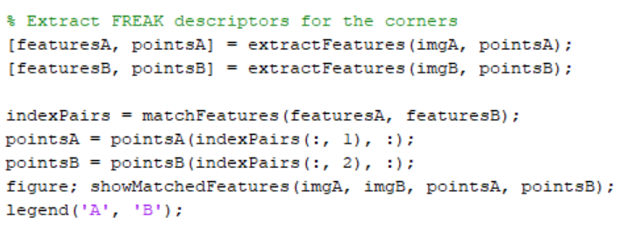

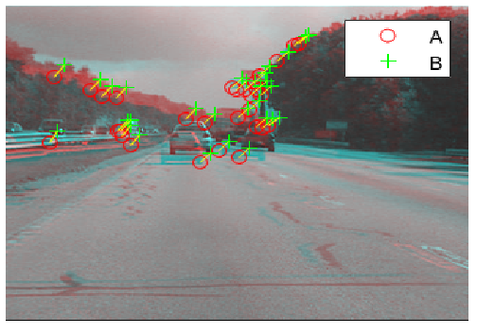

Figure 4.5. Correspondences Between Frame A and B

1. **Estimating Transform from Noisy Correspondences**

Many of the point correspondences obtained in the previous step are incorrect. But this simulaiton can still derive a robust estimate of the geometric transform between the two images using the M-estimator SAmple Consensus (MSAC) algorithm, which is a variant of the RANSAC algorithm. The MSAC algorithm is implemented in the estimateGeometricTransform function. This function, when given a set of point correspondences, will search for the valid inlier correspondences. From these it will then derive the affine transform that makes the inliers from the first set of points match most closely with the inliers from the second set. This affine transform will be a 3-by-3 matrix of the form:

(4.1)

The parameters *a* define scale, rotation, and shearing effects of the transform, while the parameters are translation parameters. This transform can be used to warp the images such that their corresponding features will be moved to the same image location.

A limitation of the affine transform is that it can only alter the imaging plane. Thus it is ill-suited to finding the general distortion between two frames taken of a 3-D scene, such as with this video taken from a moving car. But it does work under certain conditions.

Below is a color composite showing frame A overlaid with the reprojected frame B, along with the reprojected point correspondences. The results are excellent, with the inlier correspondences nearly exactly coincident. The cores of the images are both well aligned, such that the red-cyan color composite becomes almost purely black-and-white in that region.

Note how the inlier correspondences are all in the background of the image, not in the foreground, which itself is not aligned. This is because the background features are distant enough that they behave as if they were on an infinitely distant plane. Thus, even though the affine transform is limited to altering only the imaging plane, here that is sufficient to align the background planes of both images. Furthermore, if the background plane has not moved or changed significantly between frames, then this transform is actually capturing the camera motion. Therefore correcting for this will stabilize the video. This condition will hold as long as the motion of the camera between frames is small enough, or, conversely, if the video frame rate is high enough.

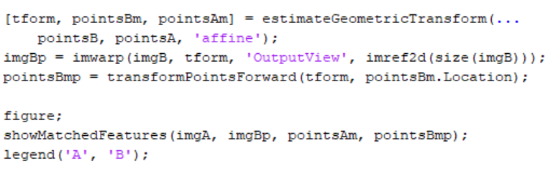

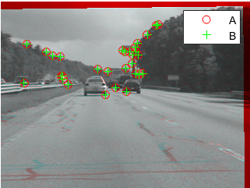

Figure 4.6. Color Composite Showing frame A overlaid with the reprojected frame B

1. **Transform Approximation and Smoothing**

This step could use all the six parameters of the affine transform above, but, for numerical simplicity and stability, some of the motion models are choosn to re-fit the matrix as a simpler scale-rotation-translation transform. This has only four free parameters compared to the full affine transform's six: one scale factor, one angle, and two translations. This new transform matrix is of the form:

(4.2)

To show that the error of converting the transform is minimal, frame B is projected with both transforms and show the two images below as a red-cyan color composite. As the image appears black and white, obviously the pixel-wise difference between the different projections is negligible.

Figure 4.7 shows example of shifting x and y directions according to reference image of the video frames which are captured from video reader. These frames are the reference frame and the current frames after the synthetic shifts. The FPGA calculates the shift values by comparing the reference and current images.

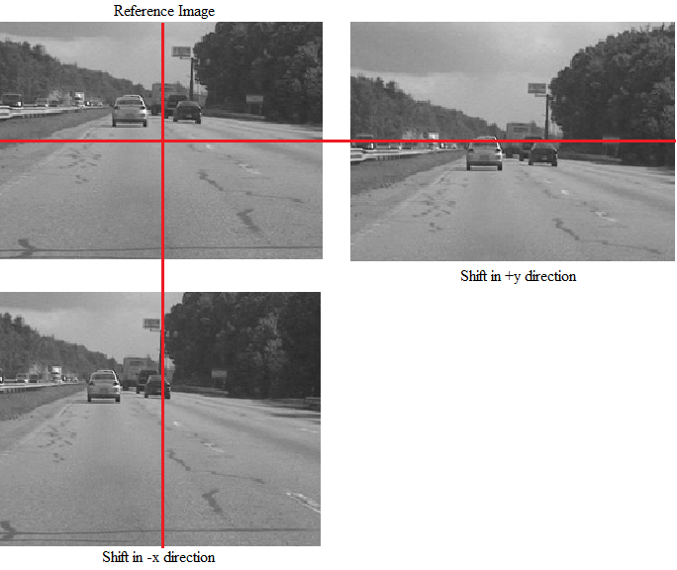

Figure 4.7. Example of Shifting x and y Directions According to Reference Image

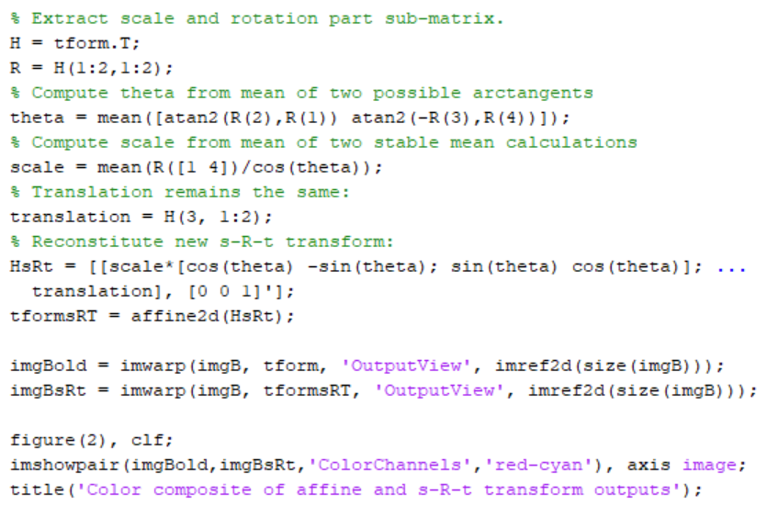

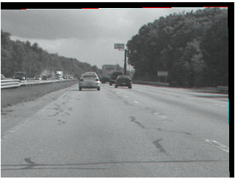

Figure 4.8. Color Composite of Affine and s-R-t Transform Outputs

1. **Run on the Full Video**

This step is applying the above steps to smooth a video sequence. For readability, the above procedure of estimating the transform between two images has been placed in the MATLAB® function cvexEstStabilizationTform. The function cvexTformToSRT also converts a general affine transform into a scale-rotation-translation transform.

At each step the transform *H* between the present frames are calculated . The frames are fitted as an s-R-t transform, *HsRt*. Then these frames are combined with the cumulative transform, *H*cumulative, which describes all camera motion since the first frame. The last two frames of the smoothed video are shown in a Video Player as a red-cyan composite.

With this code, you can also take out the early exit condition to make the loop process the entire video.

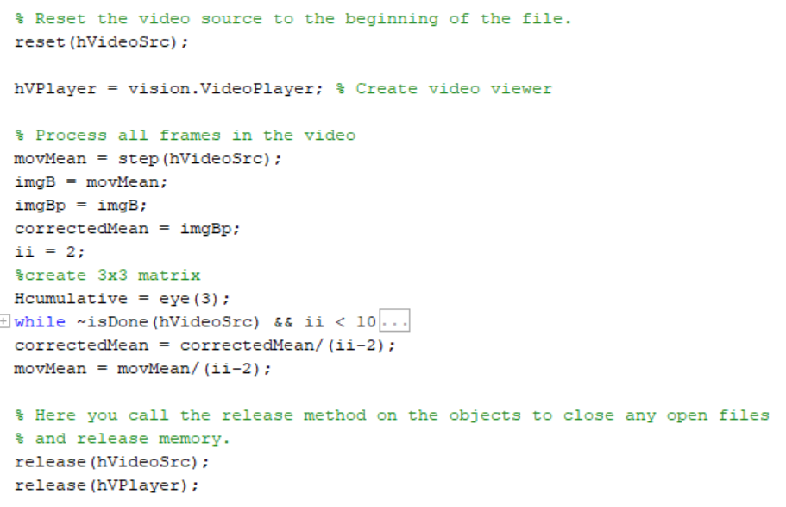

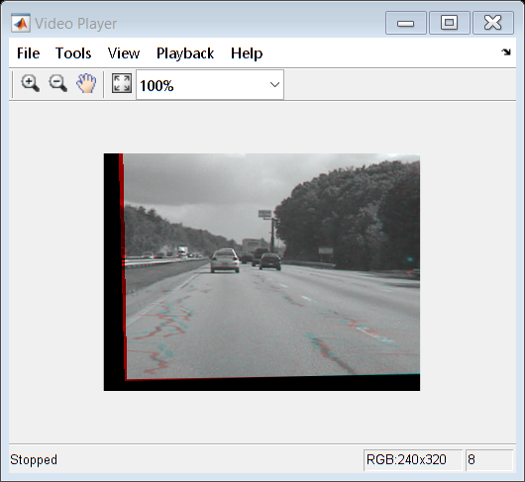

Figure 4.9. Stabilized Video in Video Player

During computation, we computed the mean of the raw video frames and of the corrected frames. These mean values are shown side-by-side below. The left image shows the mean of the raw input frames, proving that there was a great deal of distortion in the original video. The mean of the corrected frames on the right, however, shows the image core with almost no distortion. While foreground details have been blurred (as a necessary result of the car's forward motion), this shows the efficacy of the stabilization algorithm.

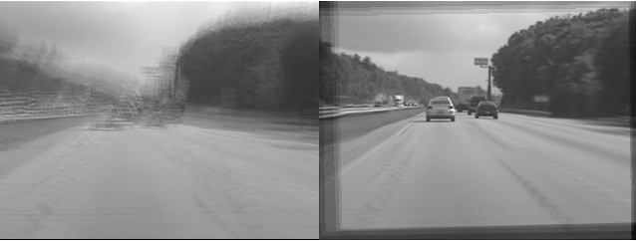

Figure 4.10. Raw Input and Corrected Sequence

1. **FPGA IMPLEMENTATION**

The FAST feature detecting algorithm has been selected for the FPGA realization because it is using the minimum amount of resources and provides sufficient accuracy in computing of the Points Feature Matching Technique. Based on the Points Feature Matching field obtained by means of FAST, digital image stabilization (DIS) algorithm has been realized. The DIS algorithm eliminates unwelcome vibrations in the movies.

PYNQ, The Xilinx® Zynq® All Programmable device is an SOC based on a dual-core ARM® Cortex®-A9 processor (referred to as the Processing System or PS), integrated with FPGA fabric (referred to as Programmable Logic or PL), is used to implement the Video Stabilization based on Points Feature Matching technique. The PS side is controlled by Jupyter notebook to run python code in the Ubuntu OS that is installed on PS. Figure 4.11 show the jupyter notebook environment that acts as a major role for input and output processes.

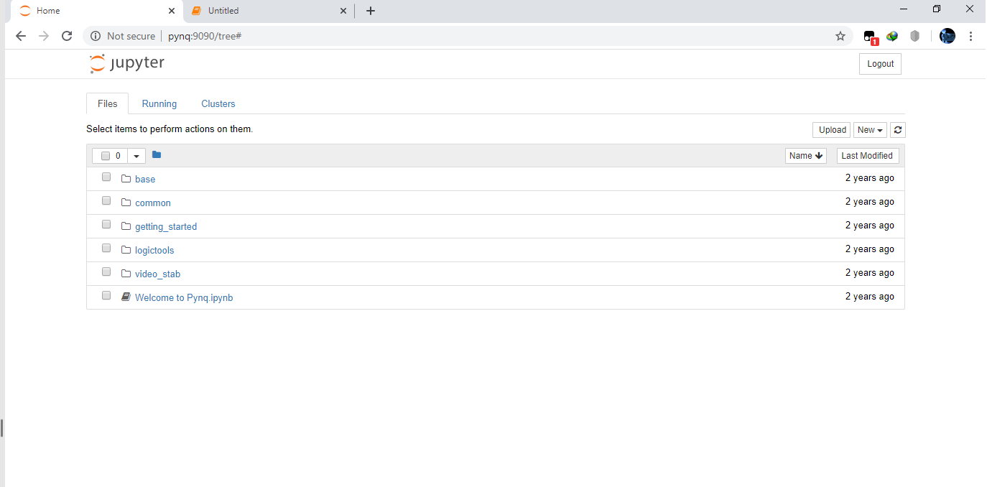

Figure 4.11. The jupyter notebook

The jupyter notebook can order the overlays. Overlay is an adaptor that is connected between the Processing System and the Programmable Logic side. Overlay takes input from PS side and send it to PL side for processing. After processing, the output sends back to PS side by using overlay. Figure 4.12 shows the flow of FPGA working procedure.

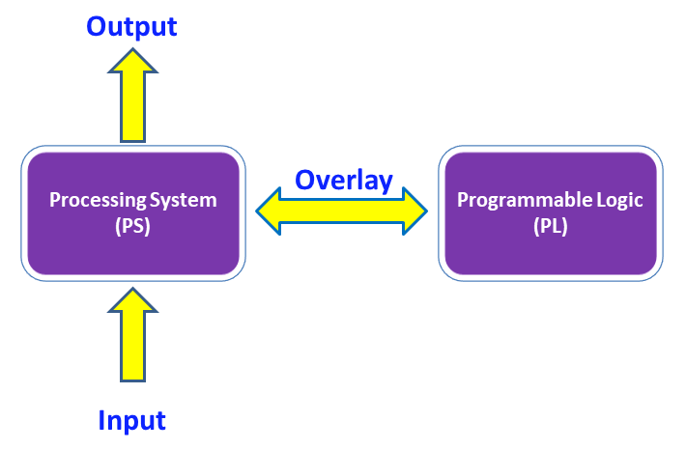

Figure 4.12. The flow of FPGA working procedure

The FPGA blocks are designed using Vivado Design Suit and Vivado HLS programming tool. The C++ code is written by Vivado HLS, and then the written C++ is converted to Intellectual property (IP) for the connection with other blocks. Figure 4.14 shows the Vivado HLS environment. The blocks are connected to ZYNQ processor and other related blocks by Vivado Design Suit to produce overlay file. Figure 4.15 shows the example of creating FPGA block design in Vivado Design Suit. Figure 4.13 shows the procedure of creating an overlay file.

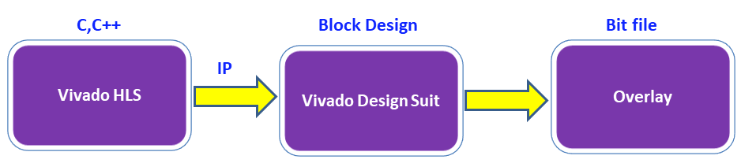

Figure 4.13. The Procedure of Creating an Overlay

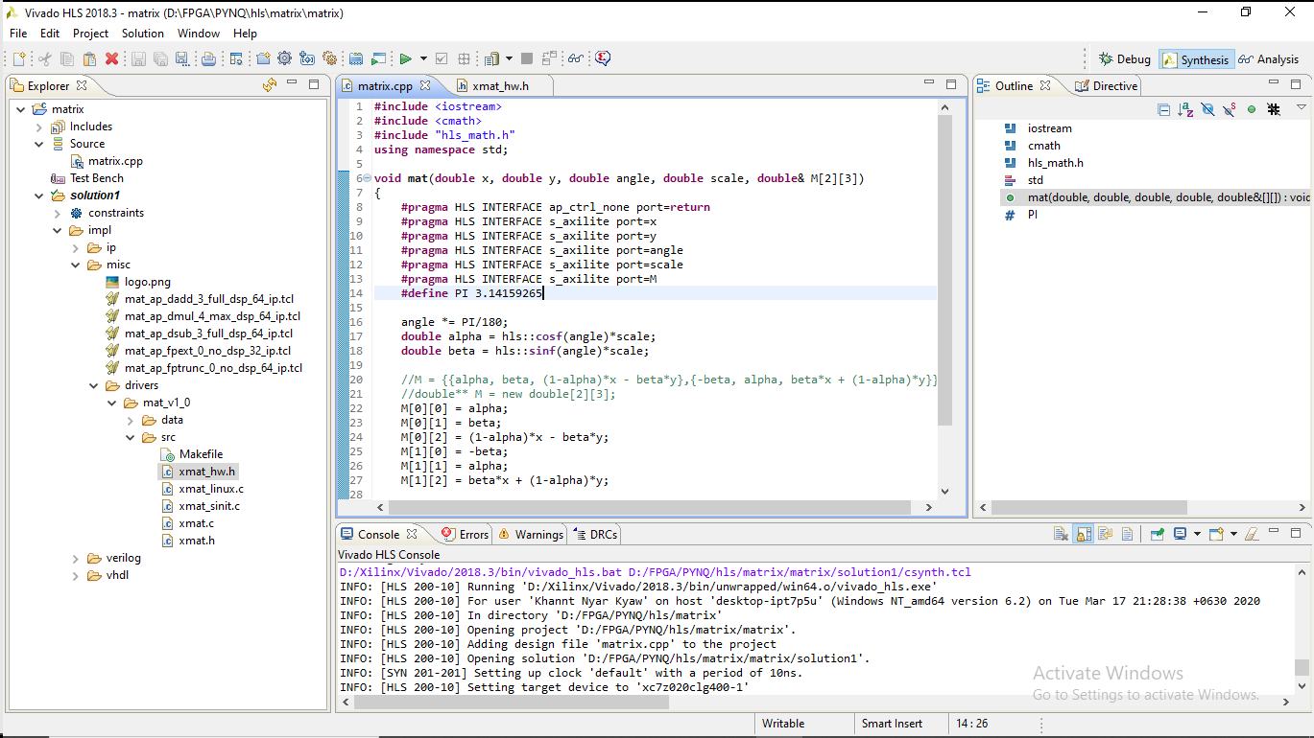

Figure 4.14. The Vivado HLS Environment

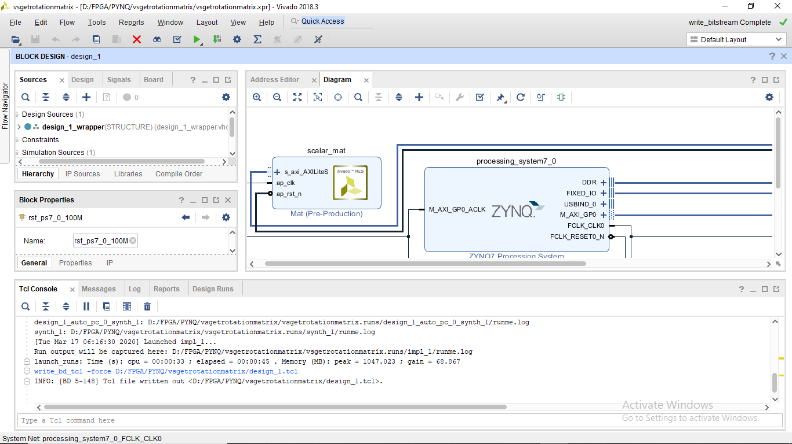

Figure 4.15. Creating Overlay in Vivado Design Suit

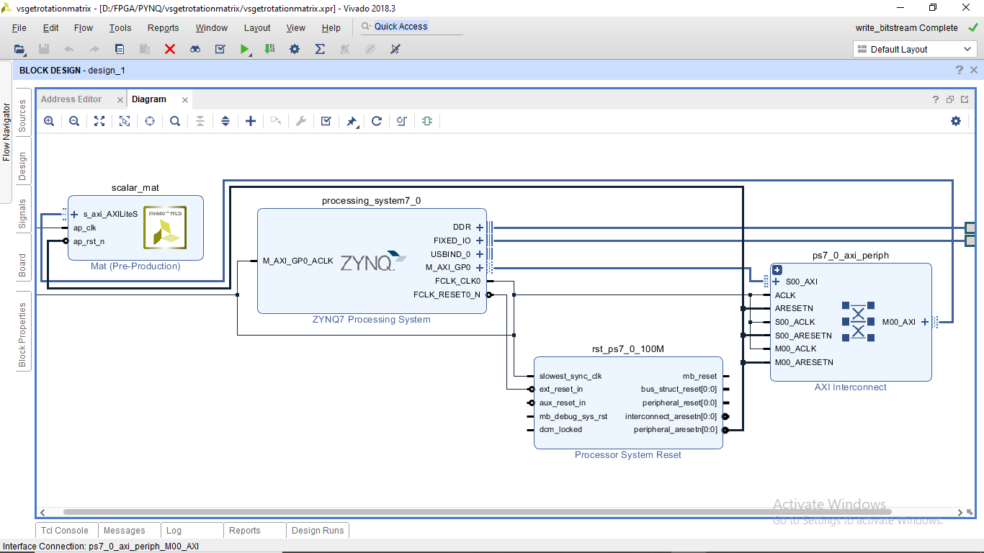

Figure 4.16. Block Design of an Overlay

After all necessary blocks are coded and connecting to each other, the design is analysed for the coding errors. Then the necessary pin assignment is completed and full compilation flow is started.

During the compilation, the programming tool generates the routing in the FPGA. It connects the input/output pins to the related blocks. Also, the timing performance of the generated routing is tested according to the constraints that the user enters at start. At the end, this flow generates a bit file which is downloaded to the FPGA.

The digital video stabilization based on Points Feature Matching method is implemented in FPGA using jupyter notebook in the PS side. In the jupyter notebook, many python functions are available for running in that PS side. For processing the function to the programmable logic (PL) side, overlay files can be used by calling function names which are coded in the vivado design suit. Figure 4.17 show some functions are written in jupyter and also call for overlay files.

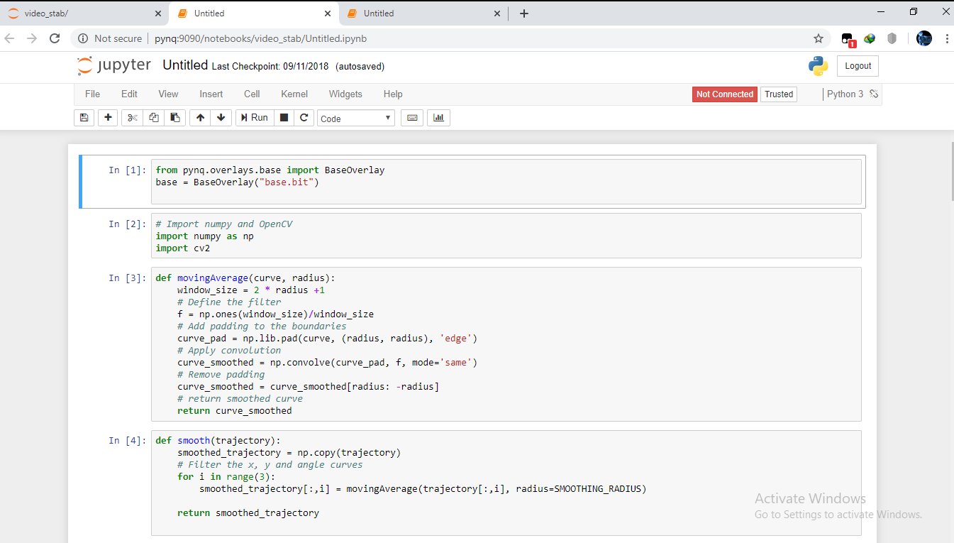

Figure 4.17. Calling Overlay file through Jupyter Notebook using python function

In FPGA implementation, FPGA is analyzing the trajectories of x-direction and y-direction and then making those trajectories to smooth. As results, the smoothed trajectories are obtained. After that, those smoothed trajectories are performed for stabilizing according to transform approximation and smoothing step. Figure 4.18 shows original trajectories and smoothed trajectories of x-direction and y-direction. Figure 4.19 shows the transformation of x-direction, y-direction and angle for stabilizing.

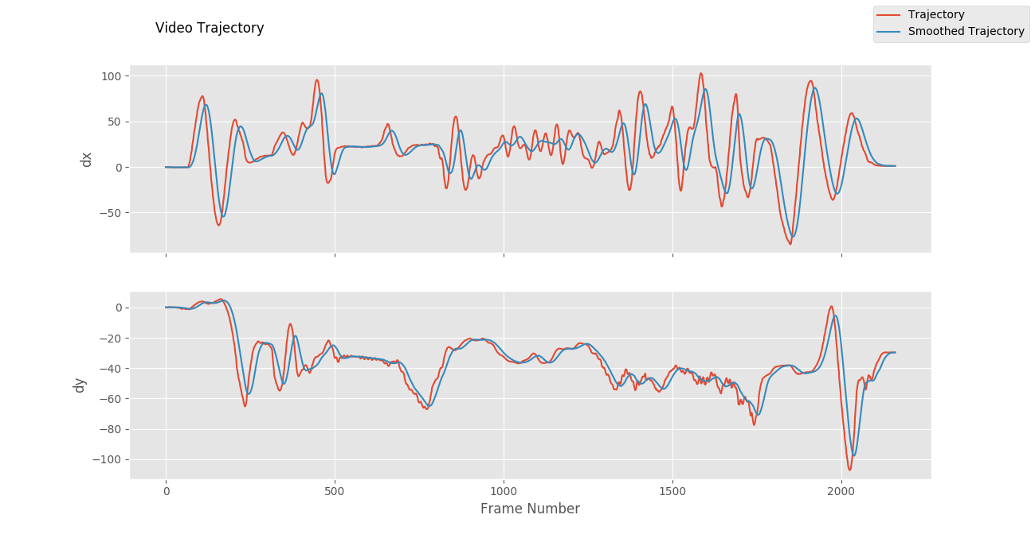

Figure 4.18. Video Trajectories in Original and Stabilized Video

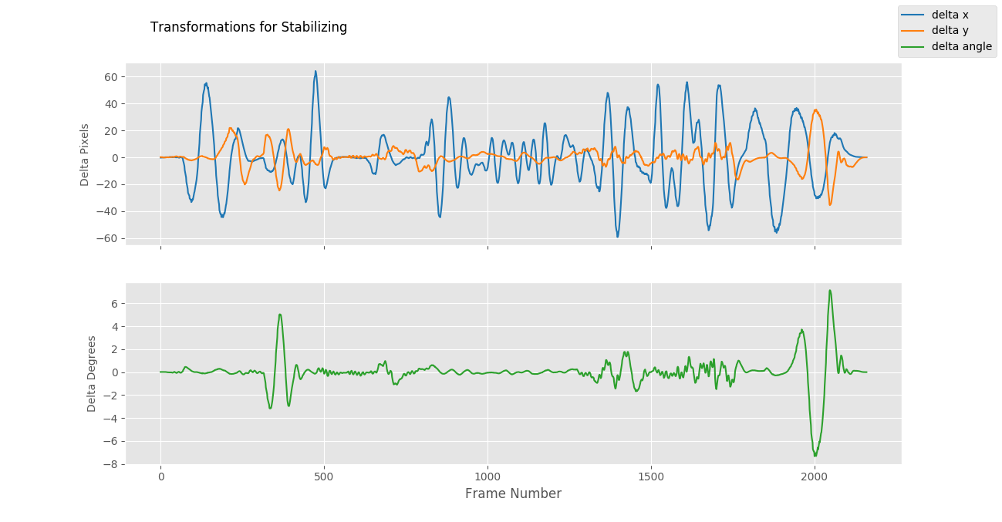

Figure 4.19. Transformation of x-direction, y-direction and angle for Stabilizing

In this implementation, the input image (resolution 650x364) has been stabilized to the output resolution 550x264. It means that the frame can be moved between +/-50 pixels (smoothing radius) in both x-axis and y-axis. The results of allowable movement pixels for each consequence frame are determined. The following Table give the implementation summary for Digital Video Stabilization via Points Feature Matching technique.

Table : FPGA Implementation Summary

|  |  |  |  |  |
| --- | --- | --- | --- | --- |
| Input Frame Resolution | Allowed x Shift (pixel) | Allowed y Shift (pixel) | Output Frame Resolution | Stabilization Quality |
| 650x364 | +/-25 | +/-25 | 600x314 | Poor |
| 650x364 | +/-50 | +/-50 | 550x264 | Good |
| 650x364 | +/-75 | +/-75 | 500x214 | Excellent |
| 650x364 | +/-100 | +/-100 | 450x164 | Good but Small Resolution |